# Alpha vs R-squared

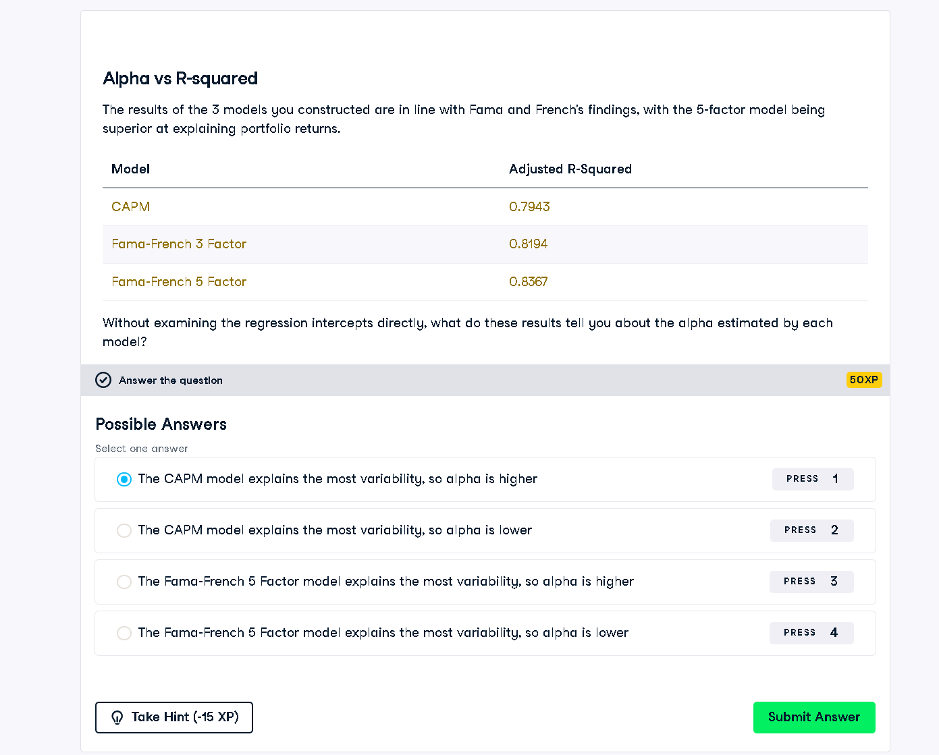

## Full Python Answer (Conceptual Interpretation)

# This is not code but rather a conceptual answer based on regression R-squared.  
# The model with the highest adjusted R-squared explains the most variability in portfolio returns,  
# meaning it leaves the least unexplained performance (alpha).  
  
# Therefore, we can infer the following:  
# Fama-French 5 Factor model explains the most variability => leaves the least alpha.  
# CAPM explains the least variability => leaves the most alpha.  
  
# Correct Answer:  
correct_option = "The Fama-French 5 Factor model explains the most variability, so alpha is lower"  
print(correct_option)

## Explanation in Simple Words (50 Words)

Adjusted R-squared shows how much of the return is explained by the model. A higher R-squared means less is left unexplained, so alpha is lower. The 5-Factor model explains more than CAPM or the 3-Factor model, so its alpha is the lowest. CAPM has the highest unexplained alpha.